**FACTORIAL OF A GIVEN NUMBER**  
**EXP NO: 9**  
**AIM:**To find the factorial of a given number using 8085 microprocessor.  
**ALGORITHM:**  
  
  
1)    Load the data into register B  
  
  
2)    To start multiplication set D to 01H  
  
  
3)    Jump to step 7  
  
  
4)   Decrements B to multiply previous number  
  
  
5)   Jump to step 3 till value of B>0  
  
  
6)    
Take memory pointer to next location and store  
result  
  
  
7)      
Load E with contents of B and clear accumulator  
  
  
8)      
Repeatedly add contents of D to accumulator E times  
  
  
9)      
Store accumulator content to D  
  
  
10) Go to  
step 4  
  
  
**PROGRAM:**  
  
  
  
LDA 2001  
  
  
MOV B,A  
  
  
MVI C,01H  
  
  
MVI E,01H  
  
  
LOOP: MOV D,C  
  
  
MVI A,00H  
  
  
LP: ADD E  
  
  
DCR D  
  
  
JNZ LP  
  
  
MOV E,A  
  
  
INR C  
  
  
DCR B  
  
  
JNZ LOOP  
  
  
MOV A,E  
  
  
STA 2010  
  
  
HLT  
  
 

**INPUT:**

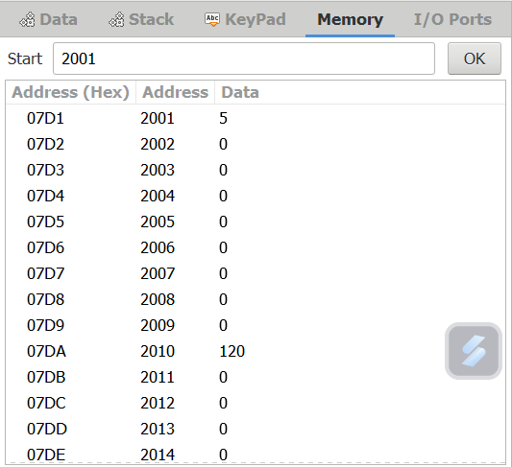  
**OUTPUT:**  
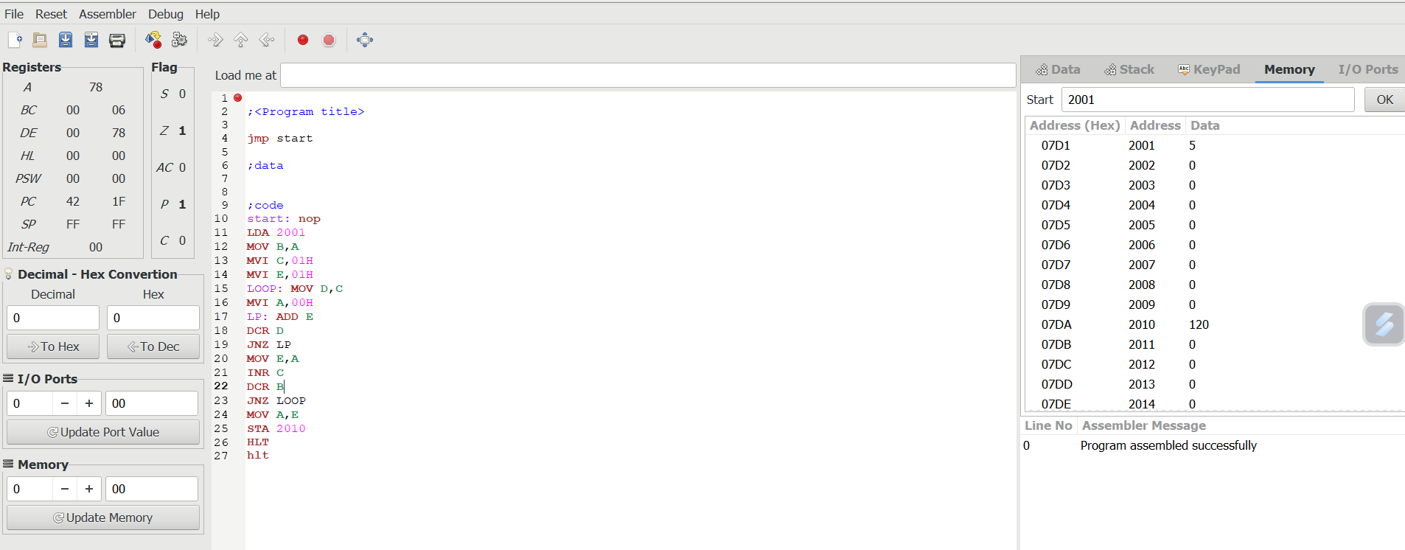  
  
**RESULT:**Thus the program was executed successfully using 8085  
processor simulator.